

Experiment - 10

Student Name: Chandan Kumar | UID: 23BAI70147
Branch: BE-AIT-CSE | Section/Group: 23AIT_KRG-G1_A
Semester: 5th | Date of Performance: 29 Oct, 2025
Subject Name: ADBMS | Subject Code: 23CSP-333

- Aim:

To study and perform basic CRUD (Create, Read, Update, Delete) operations in MongoDB, a NoSQL document-based database, and understand its key commands, such as creating databases, collections, inserting, updating, deleting records, and grouping data using aggregation.

- Objective:

  - To understand the concept of NoSQL and document-based databases.
  - To learn how to create and manage databases and collections in MongoDB.
  - To perform CRUD operations — Create, Read, Update, and Delete — on MongoDB collections.
  - To use operators like $push, $pull, $unset, and $upsert for document updates.
  - To execute conditional queries and retrieve nested document data using find().
  - To perform grouping and aggregation operations using $sum and other aggregation operators.
  - To compare SQL and NoSQL databases in terms of structure, performance, and use cases.
  - To apply MongoDB commands on a practical dataset (e.g., car dealership data) for handson understanding.

- Theory:

MongoDB is a NoSQL document-oriented database that stores data in JSON-like documents instead of tables and rows. It is designed for handling large, unstructured, or semi-structured data with flexibility and scalability.
A MongoDB database contains collections, and each collection holds multiple documents made up of key-value pairs. Unlike SQL databases, MongoDB allows documents in the same collection to have different structures, making it ideal for applications with changing data requirements.

Basic Operations:
    - Create: use db_name, db.createCollection()
    - Insert: insertOne(), insertMany()
    - Read: find(), findOne()
    - Update: updateOne(), updateMany() with $set, $push, $pull, $upsert
    - Delete: deleteOne(), deleteMany()
MongoDB also supports aggregation (e.g., $sum, $group) for analyzing and summarizing data.

Advantages:
    - Flexible and schema-less structure
    - High performance and scalability
    - Easy integration with modern applications
In short, MongoDB is preferred for applications requiring speed, flexibility, and scalability, while SQL remains suited for structured and relational data.

- Procedure:

    - Start the MongoDB server and open the Mongo shell or MongoDB Compass.
    - Create or switch to a new database.
    - Create a new collection to store data.
    - Insert one or more documents into the collection.
    - Retrieve data from the collection using read operations.
    - Apply filters or conditions to view specific data.
    - Update existing records in the collection as required.
    - Delete one or multiple records from the collection.
    - Perform grouping or aggregation operations to analyze data.
    - Drop collections or the entire database if no longer needed.

- Code:

C:\Users\Armaa>mongosh
Current Mongosh Log ID: 690a30cdd72ea166af63b111
Connecting to:
mongodb://127.0.0.1:27017/?directConnection=true&serverSelectionTimeoutMS=2000&appName=mongosh+2.5.9 Using MongoDB: 8.2.1
Using Mongosh: 2.5.9

For mongosh info see: https://www.mongodb.com/docs/mongodb-shell/

To help improve our products, anonymous usage data is collected and sent to MongoDB periodically (https://www.mongodb.com/legal/privacy-policy).
You can opt-out by running the disableTelemetry() command.

------
The server generated these startup warnings when booting
2025-11-04T22:18:13.154+05:30: Access control is not enabled for the database. Read and write access to data and configuration is unrestricted
------

test> db.createCollection("cars")
{ ok: 1 } test> db.cars test.cars test> {
... "maker": "Tata",
... "model": "Nexon",
... "fuel_type": "Petrol",
... "transmission": "Automatic",
... "engine": {
... "type": "Turbocharged",
... "cc": 1199,
... "torque": "170 Nm"
... },
... "features": [
... "Touchscreen",
... "Reverse Camera",
... "Bluetooth Connectivity"
... ],
... "sunroof": false,
... "airbags": 2 ... } ...
...
test> db.cars.insertOne ()
MongoshInvalidInputError: [COMMON-10001] Missing required argument at position 0 (Collection.insertOne) test> db.cars.insertOne(
... {
... "maker": "Tata",
... "model": "Nexon",
... "fuel_type": "Petrol",
... "transmission": "Automatic",
... "engine": {
... "type": "Turbocharged",
... "cc": 1199,
... "torque": "170 Nm"
... },
... "features": [
... "Touchscreen",
... "Reverse Camera",
... "Bluetooth Connectivity"
... ],
... "sunroof": false,
... "airbags": 2
... })
{ acknowledged: true,
insertedId: ObjectId('690a31c2d72ea166af63b112')
} test> db.cars.insertMany(
... [
... {
... "maker": "Hyundai",
... "model": "Creta",
... "fuel_type": "Diesel",
... "transmission": "Manual",
... "engine": {
... "type": "Naturally Aspirated",
... "cc": 1493,
... "torque": "250 Nm"
... },
... "features": [
... "Sunroof",
... "Leather Seats",
... "Wireless Charging",
... "Ventilated Seats",
... "Bluetooth"
... ],
... "sunroof": true,
... "airbags": 6
... },
... {
... "maker": "Maruti Suzuki",
... "model": "Baleno",
... "fuel_type": "Petrol",
... "transmission": "Automatic",
... "engine": {
... "type": "Naturally Aspirated",
... "cc": 1197,
... "torque": "113 Nm"
... },
... "features": [
... "Projector Headlamps",
... "Apple CarPlay",
... "ABS"
... ],
... "sunroof": false,
... "airbags": 2
... },
... {
... "maker": "Mahindra",
... "model": "XUV500",
... "fuel_type": "Diesel",
... "transmission": "Manual",
... "engine": {
... "type": "Turbocharged",
... "cc": 2179,
... "torque": "360 Nm"
... },
... "features": [
... "All-Wheel Drive",
... "Navigation System",
... "Cruise Control"
... ],
... "sunroof": true,
... "airbags": 6
... },
... {
... "maker": "Honda",
... "model": "City",
... "fuel_type": "Petrol",
... "transmission": "Automatic",
... "engine": {
... "type": "Naturally Aspirated",
... "cc": 1498,
... "torque": "145 Nm"
... },
... "features": [
... "Keyless Entry",
... "Auto AC",
... "Multi-angle Rearview Camera"
... ],
... "sunroof": false,
... "airbags": 4
... }
... ])
{ acknowledged: true, insertedIds: {
'0': ObjectId('690a31e6d72ea166af63b113'),
'1': ObjectId('690a31e6d72ea166af63b114'),
'2': ObjectId('690a31e6d72ea166af63b115'),
'3': ObjectId('690a31e6d72ea166af63b116')
} }
test> db.cars.find()
[
{
_id: ObjectId('690a31c2d72ea166af63b112'),
maker: 'Tata', model: 'Nexon', fuel_type: 'Petrol', transmission: 'Automatic', engine: { type: 'Turbocharged', cc: 1199, torque: '170 Nm' }, features: [ 'Touchscreen', 'Reverse Camera', 'Bluetooth Connectivity' ], sunroof: false, airbags: 2
},
{
_id: ObjectId('690a31e6d72ea166af63b113'),
maker: 'Hyundai', model: 'Creta', fuel_type: 'Diesel', transmission: 'Manual', engine: { type: 'Naturally Aspirated', cc: 1493, torque: '250 Nm' }, features: [ 'Sunroof',
'Leather Seats',
'Wireless Charging',
'Ventilated Seats',
'Bluetooth'
],
sunroof: true, airbags: 6
},
{
_id: ObjectId('690a31e6d72ea166af63b114'),
maker: 'Maruti Suzuki', model: 'Baleno', fuel_type: 'Petrol', transmission: 'Automatic', engine: { type: 'Naturally Aspirated', cc: 1197, torque: '113 Nm' }, features: [ 'Projector Headlamps', 'Apple CarPlay', 'ABS' ],
sunroof: false, airbags: 2
},
{
_id: ObjectId('690a31e6d72ea166af63b115'), maker: 'Mahindra',
model: 'XUV500', fuel_type: 'Diesel', transmission: 'Manual', engine: { type: 'Turbocharged', cc: 2179, torque: '360 Nm' }, features: [ 'All-Wheel Drive', 'Navigation System', 'Cruise Control' ], sunroof: true, airbags: 6
},
{
_id: ObjectId('690a31e6d72ea166af63b116'),
maker: 'Honda', model: 'City', fuel_type: 'Petrol', transmission: 'Automatic', engine: { type: 'Naturally Aspirated', cc: 1498, torque: '145 Nm' }, features: [ 'Keyless Entry', 'Auto AC', 'Multi-angle Rearview Camera' ], sunroof: false, airbags: 4
}
]
test> db.cars.findOne()
{
_id: ObjectId('690a31c2d72ea166af63b112'),
maker: 'Tata', model: 'Nexon', fuel_type: 'Petrol', transmission: 'Automatic', engine: { type: 'Turbocharged', cc: 1199, torque: '170 Nm' }, features: [ 'Touchscreen', 'Reverse Camera', 'Bluetooth Connectivity' ], sunroof: false, airbags: 2 }
test> db.cars.find({},{model:1})
[
{ _id: ObjectId('690a31c2d72ea166af63b112'), model: 'Nexon' },
{ _id: ObjectId('690a31e6d72ea166af63b113'), model: 'Creta' },
{ _id: ObjectId('690a31e6d72ea166af63b114'), model: 'Baleno' },
{ _id: ObjectId('690a31e6d72ea166af63b115'), model: 'XUV500' },
{ _id: ObjectId('690a31e6d72ea166af63b116'), model: 'City' }
]
test> db.cars.find({},{model:1,_id:0})
[
{ model: 'Nexon' },
{ model: 'Creta' },
{ model: 'Baleno' },
{ model: 'XUV500' },
{ model: 'City' }
]
test> db.cars.find({},{model:1,maker:1,_id:0})
[
{ maker: 'Tata', model: 'Nexon' },
{ maker: 'Hyundai', model: 'Creta' },
{ maker: 'Maruti Suzuki', model: 'Baleno' },
{ maker: 'Mahindra', model: 'XUV500' },
{ maker: 'Honda', model: 'City' }
]
test> db.cars.find(fuel_type:"Petrol") Uncaught:
SyntaxError: Unexpected token, expected "," (1:22)

> 1 | db.cars.find(fuel_type:"Petrol")
| ^
2 |

test> db.cars.find("fuel_type":"Petrol") Uncaught:
SyntaxError: Unexpected token, expected "," (1:24)

> 1 | db.cars.find("fuel_type":"Petrol")
| ^
2 |

test> db.cars.find({"fuel_type":"Petrol"})
[
{
_id: ObjectId('690a31c2d72ea166af63b112'),
maker: 'Tata', model: 'Nexon', fuel_type: 'Petrol', transmission: 'Automatic',
engine: { type: 'Turbocharged', cc: 1199, torque: '170 Nm' }, features: [ 'Touchscreen', 'Reverse Camera', 'Bluetooth Connectivity' ], sunroof: false, airbags: 2
},
{
_id: ObjectId('690a31e6d72ea166af63b114'),
maker: 'Maruti Suzuki', model: 'Baleno', fuel_type: 'Petrol', transmission: 'Automatic', engine: { type: 'Naturally Aspirated', cc: 1197, torque: '113 Nm' }, features: [ 'Projector Headlamps', 'Apple CarPlay', 'ABS' ],
sunroof: false, airbags: 2
},
{
_id: ObjectId('690a31e6d72ea166af63b116'),
maker: 'Honda', model: 'City', fuel_type: 'Petrol', transmission: 'Automatic', engine: { type: 'Naturally Aspirated', cc: 1498, torque: '145 Nm' }, features: [ 'Keyless Entry', 'Auto AC', 'Multi-angle Rearview Camera' ], sunroof: false, airbags: 4
}
]
test> db.cars.updateOne( ... { model: "Nexon" },
... { $set: { color: "Red" } }
... ) ...
{ acknowledged: true, insertedId: null, matchedCount: 1, modifiedCount: 1, upsertedCount: 0
} test> db.cars.updateOne(
... { model: "Nexon" },
... { $push: { features: "Heated Seats" } }
... ) ...
{ acknowledged: true, insertedId: null, matchedCount: 1, modifiedCount: 1, upsertedCount: 0
} test> db.cars.updateOne(
... { model: "Nexon" },
... { $pull: { features: "Heated Seats" } }
... )
...
{ acknowledged: true, insertedId: null, matchedCount: 1, modifiedCount: 1, upsertedCount: 0
}
test> db.cars.updateMany( ... { fuel_type: "Diesel" },
... { $set: { alloys: "yes" } }
... ) ...
{ acknowledged: true, insertedId: null, matchedCount: 2, modifiedCount: 2, upsertedCount: 0
}
test> db.cars.updateOne(
... { model: "Creta" },
... { $set: { "engine.torque": "270 Nm" } }
... ) ...
{ acknowledged: true, insertedId: null, matchedCount: 1, modifiedCount: 1, upsertedCount: 0
} test> db.cars.updateOne(
... { model: "Nexon" },
... { $push: { features: "Heated Steering Wheel" } }
... ) ...
{ acknowledged: true, insertedId: null, matchedCount: 1, modifiedCount: 1, upsertedCount: 0
} test> db.cars.updateOne(
... { model: "Nexon" },
... { $pull: { features: "Bluetooth Connectivity" } }
... ) ...
{ acknowledged: true, insertedId: null, matchedCount: 1, modifiedCount: 1, upsertedCount: 0
} test> db.cars.updateOne(
... { model: "Nexon" },
... { $push: { features: { $each: ["Wireless charging", "Voice Control"] } } }
... ) ...
{ acknowledged: true, insertedId: null, matchedCount: 1, modifiedCount: 1, upsertedCount: 0
}
test> db.cars.updateOne( ... { model: "Nexon" },
... { $unset: { color: "" } }
... ) ...
{ acknowledged: true, insertedId: null, matchedCount: 1, modifiedCount: 1, upsertedCount: 0
}
test> db.cars.updateMany(
... {},
... { $set: { color: "Blue" } }
... ) ...
{ acknowledged: true, insertedId: null, matchedCount: 5, modifiedCount: 5, upsertedCount: 0
}
test> db.cars.aggregate([
... {
... $group: {
... _id: "$maker",
... TotalCars: { $sum: 1 }
... }
... } ... ]) ...
[
{ _id: 'Maruti Suzuki', TotalCars: 1 },
{ _id: 'Tata', TotalCars: 1 },
{ _id: 'Hyundai', TotalCars: 1 },
{ _id: 'Honda', TotalCars: 1 },
{ _id: 'Mahindra', TotalCars: 1 }
]
test> db.cars.aggregate([
... {
... $group: {
... _id: "$fuel_type",
... TotalCars: { $sum: 1 }
... }
... } ... ]) ...
[ { _id: 'Petrol', TotalCars: 3 }, { _id: 'Diesel', TotalCars: 2 } ]
test> db.collection.aggregate([
... {
... $group: {
... _id: "$category",
... totalAmount: { $sum: "$amount" },
... averageAmount: { $avg: "$amount" },
... minAmount: { $min: "$amount" },
... maxAmount: { $max: "$amount" },
... amountsList: { $push: "$amount" },
... uniqueAmounts: { $addToSet: "$amount" }
... }
... } ... ]) ...

test>

- Output:
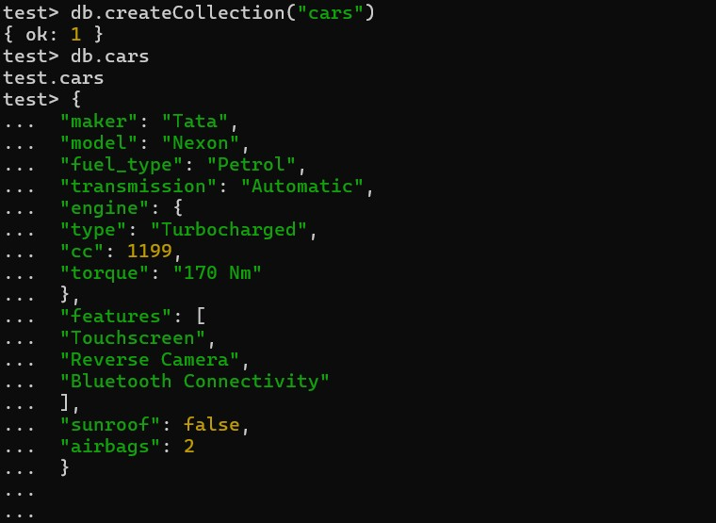
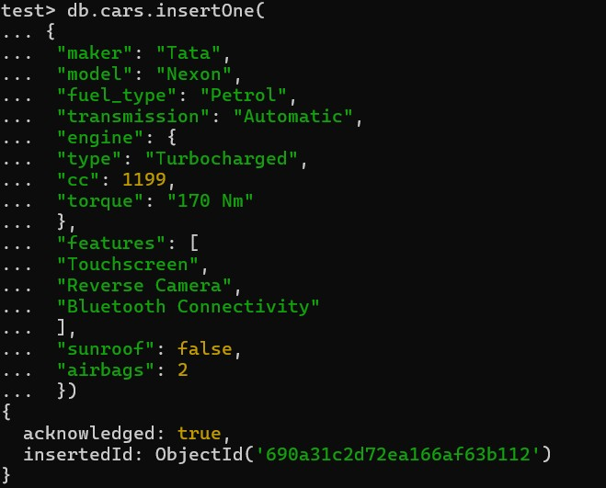

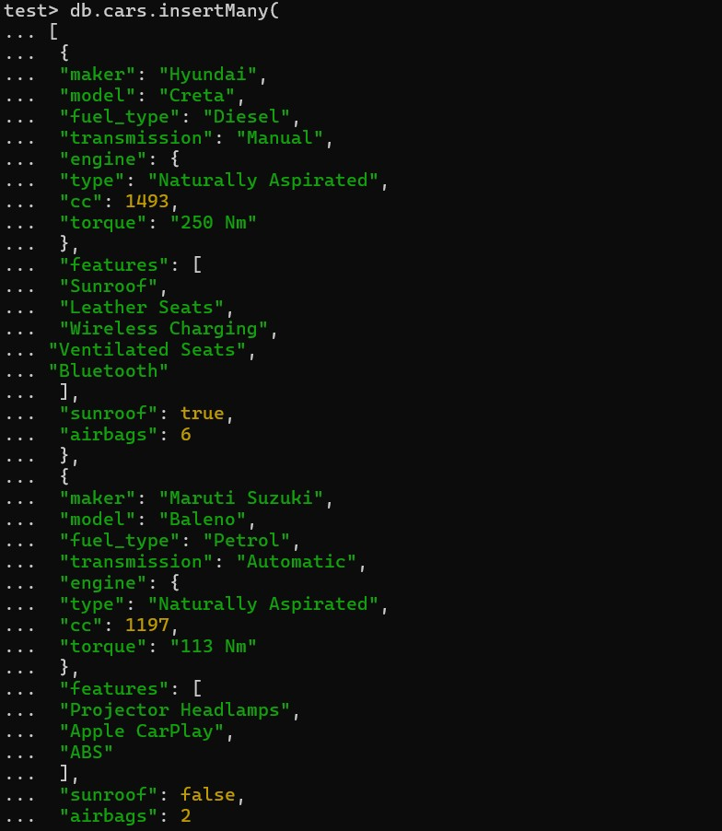
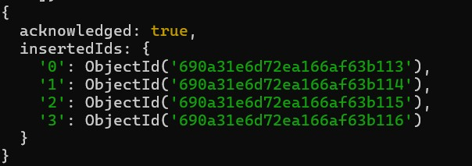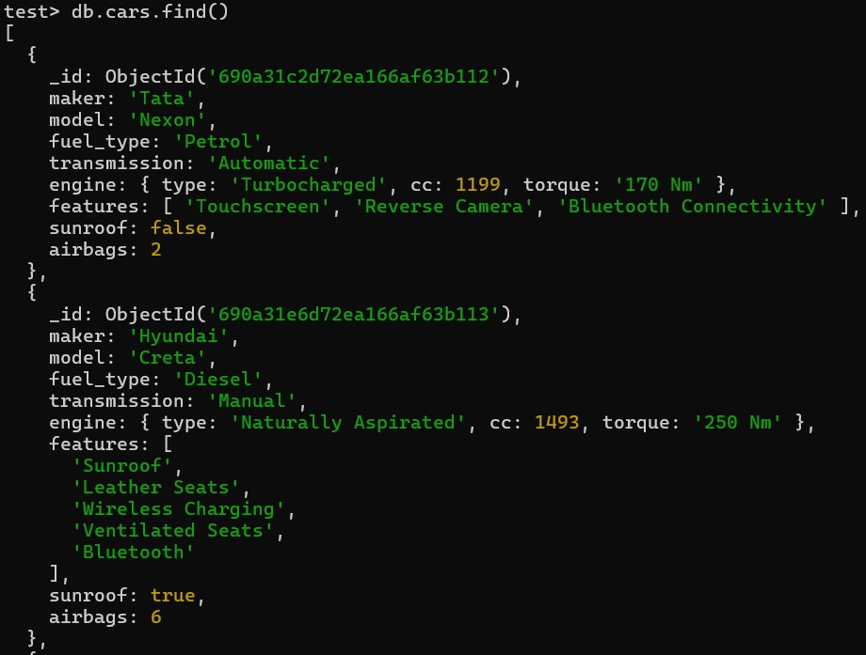

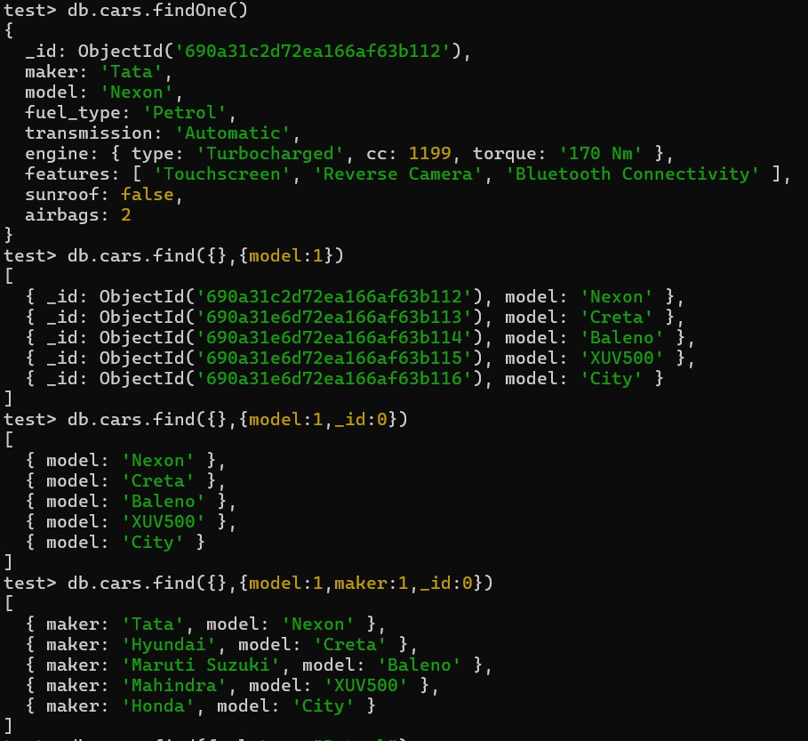
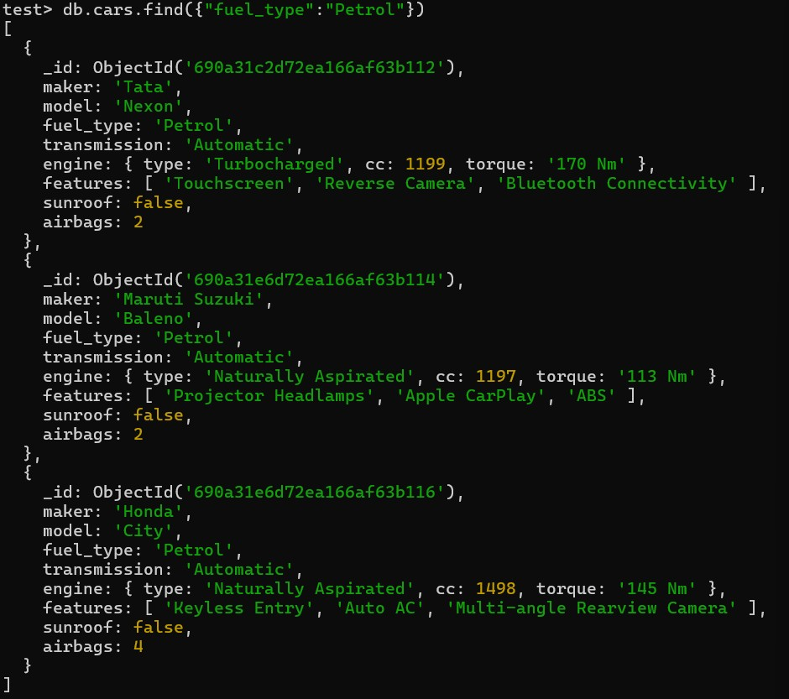
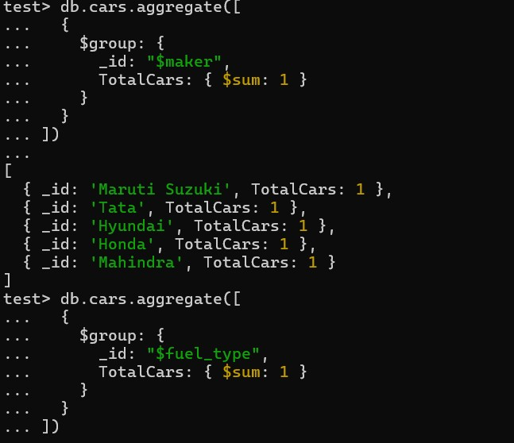

- Learning Outcomes:
  - Understand the concept of NoSQL databases and their differences from SQL databases.
  - Gain knowledge of MongoDB architecture, including databases, collections, and documents.
  - Learn to perform CRUD operations (Create, Read, Update, Delete) using MongoDB commands.
  - Use operators such as $set, $push, $pull, $unset, and $upsert for data manipulation.
  - Apply aggregation and grouping operations using operators like $sum, $avg, $min, and $max.
  - Develop the ability to query and analyze data efficiently in MongoDB.
  - Compare the advantages and use cases of SQL vs NoSQL database models.
  - Gain practical experience handling real-world data (e.g., car dealership dataset) using
MongoDB.

